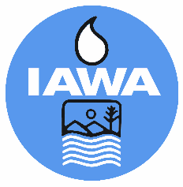
MEMBER REGISTRATION FORM
Illinois Association of Wastewater Agencies
Technical Committee Meeting
May 10, 2024 @ 10 AM
Starved Rock Lodge, Utica, IL
Agency:
Billing Address:
Phone Number:

Name (s) | $65/$75 Late Registration
TOTAL $

CANCELLATIONS MUST BE RECEIVED IN WRITING BY THE IAWA OFFICE NO LATER THAN May 3, 2023 BEFORE 4 PM TO RECEIVE A REFUND.
Check Enclosed
Bill Me
Pay by Credit Card via Paypal (Do not provide cc# on form)
Email address to send Paypal Invoice

Please make check payable to IAWA and email or mail with registration form to:
IAWA
ATTN: Penny Williams
241 North 5th Street
Springfield, IL 62701
217/523-1814
Fax: 217/544-0086
Williams.penny@comcast.net or dobbins.robin@comcast.net

