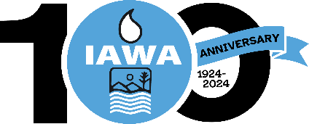
MEMBER REGISTRATION FORM
Illinois Association of Wastewater Agencies
100th Anniversary – Sept. 17 – 19, 2024
Wyndham John Deere Commons, Moline, IL
Starved Rock Lodge, Utica, IL
Name:
Agency:
Billing Address:
Phone Number:
Each person attending must fill out a separate form.
You must be a member of IAWA or a guest of a member to attend.
Registration fee for attending all Events | $400.00
If you will not be attending the following events, you may deduct the GSA Per Diem for the area.
I will not be attending the Wednesday Lunch | ($15.00)
I will not be attending the Thursday Lunch | ($15.00)
For head count purposes, please indicate if you will be attending:
I will be attending the Tuesday Reception
I will be attending the Dinner Cruise on Wednesday
TOTAL
CANCELLATIONS MUST BE RECEIVED IN WRITING BY THE IAWA OFFICE NO LATER THAN September 9, 2024 BEFORE 4 PM TO RECEIVE A REFUND.
Check Enclosed
Bill Me
Pay by Credit Card via Paypal (Do not provide cc# on form)
Email address to send Paypal Invoice
Please make check payable to IAWA and email or mail with registration form to:
IAWA
ATTN: Penny Williams
241 North 5th Street
Springfield, IL 62701
217/523-1814
Fax: 217/544-0086
Williams.penny@comcast.net or dobbins.robin@comcast.net

