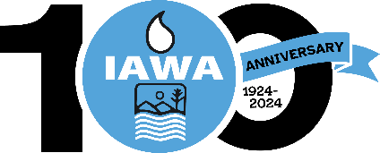
SPOUSE REGISTRATION FORM
Illinois Association of Wastewater Agencies
100th Anniversary – Sept. 17 – 19, 2024
Wyndham John Deere Commons, Moline, IL
Starved Rock Lodge, Utica, IL
Name:
Spouse’s Name:
Billing Address:
Phone Number:

Registration fee for attending Tuesday Welcome Reception and Wednesday Dinner Cruise | $150.00

CANCELLATIONS MUST BE RECEIVED IN WRITING BY THE IAWA OFFICE NO LATER THAN September 9, 2024 BEFORE 4 PM TO RECEIVE A REFUND.

Check Enclosed
Bill Me
Pay by Credit Card via Paypal (Do not provide cc# on form)
Email address to send Paypal Invoice

Please make check payable to IAWA and email or mail with registration form to:
IAWA
ATTN: Penny Williams
241 North 5th Street
Springfield, IL 62701
217/523-1814
Fax: 217/544-0086
Williams.penny@comcast.net or dobbins.robin@comcast.net

