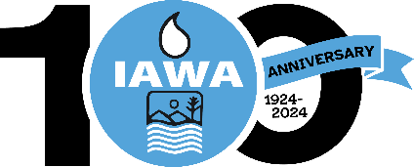
TRUSTEE ROUNDTABLE/FORUM REGISTRATION FORM
Illinois Association of Wastewater Agencies
100th Anniversary – Sept. 17 – 19, 2024
Wyndham John Deere Commons, Moline, IL
Name:
Agency:
Billing Address:
Phone Number:
Each person attending must fill out a separate form.
You must be a member of IAWA or a guest of a member to attend.
Registration fee for Trustees to attend Roundtable/Forum  Tuesday Reception and Wednesday AM Technical Session/Lunch Only. If planning to attend Wednesday Banquet, a full member registration form will be required | $100.00

CANCELLATIONS MUST BE RECEIVED IN WRITING BY THE IAWA OFFICE NO LATER THAN September 9, 2024 BEFORE 4 PM TO RECEIVE A REFUND.
Check Enclosed
Bill Me
Pay by Credit Card via Paypal (Do not provide cc# on form)
Email address to send Paypal Invoice
Please make check payable to IAWA and email or mail with registration form to:
IAWA
ATTN: Penny Williams
241 North 5th Street
Springfield, IL 62701
217/523-1814
Fax: 217/544-0086
Williams.penny@comcast.net or dobbins.robin@comcast.net

