AGENDA
2025 IAWA Annual Conference
September 16-18, 2025 - I-Hotel– Champaign, IL

TUESDAY, SEPTEMBER 16, 2025

2:00 PM - Registration

4:00 – 5:30 PM Trustee Event – Knowledge Room

5:30 – 7:00 PM Welcome Reception – Humanities Room

WEDNESDAY, SEPTEMBER 17, 2025

TECHNICAL SESSIONS – Illinois B/C Ballroom

8:00 AM Registration

8:00 – 9:30 AM Continental Breakfast will be provided at Technical Session

9:00 – 9:45 AM “Infrastructure Asset Management: Is AI a New Solution to an old Problem”
Matt Buerger, PE
Farnsworth Group

9:45 – 10:30 AM “AI Technology Digital Model”
Mark Drake, Digital Business Manager, North America
Veolia Water Technologies

10:30 – 10:45 AM Break

10:45 – 11:30 AM “IEPA Update”
Nidhan Singh, Fund Manager
IEPA

11:30 AM – 1:00 PM Lunch – Illinois A Ballroom

IAWA/IEPA Lunch – Excellence Room

1:00 – 1:45 PM “Employment /Labor Law Update”
Abby Clark, Attorney
Davis & Campbell, LLC

1:45 – 2:30 PM “Nutrient Trading in Illinois – Battling “The Devil’s Element” with a return to Eden”
Bartlett Durand
Local Choice Marketing, LLC
2:30 – 2:45 PM Break

2:45 – 3:15 PM Business/Technical Meeting

3:15– 3:45 PM “Legislative Update”
Mike Grady, Derek Blaida, IAWA Lobbyists
Strategic Advocacy Group

5:00 – 6:00 PM Annual Awards Reception and Induction of Officers
(Bus transportation will be provided Graceful Acres Flower Farm
with pick up at 4:15 PM/9:00 PM departure) Monticello, IL

Floral Arranging Add On at Graceful Acres Flower Farm - Floral arranging will be offered to anyone
interested during the Reception with the following Options (personal pay):

Mason Jar Free Design (no floral support) $40/person
Professional Footed Vase with reusable design support $65/person

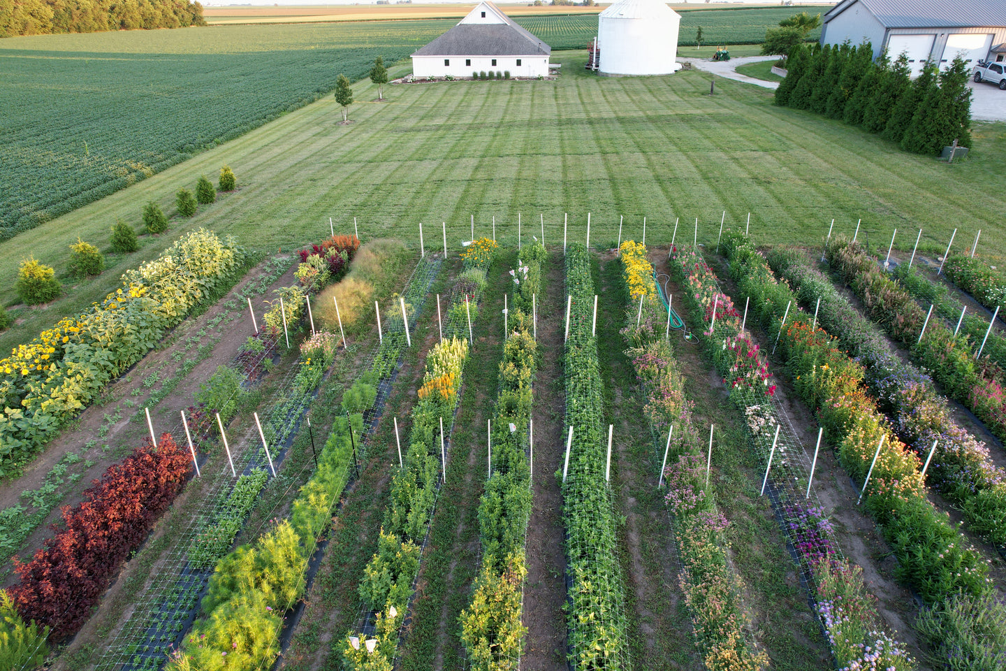

6:00 – 9:00 PM Dinner/Entertainment with High Cotton https://highcottonbg.weebly.com/

THURSDAY, SEPTEMBER 18, 2025

TECHNICAL SESSIONS – Illinois B/C Ballroom

8:00 – 9:30 AM Continental Breakfast will be provided at Technical Session

9:00 a.m. – 9:45 a.m. “PFAS Regulatory Update and IAWA Activities”
Fred Andes, Partner
Barnes & Thornberg

9:45 a.m. – 10:30 a.m. “Drone System” Multi-sensor Fugitive Methane Investigation at City of Columbus Southerly Wastewater Treatment Plant”
Stacia Eckenwiler, Assistant Administrator
City of Columbus

10:30– 10:45 a.m. Break

10:45 a.m. – 11:30 a.m. “Ethics Training-Recent Cases from the Board of Ethical Review” Michael C. Loui, Professor Emeritus of Electrical & Computer Eng.
University of Illinois-Champaign/Urbana

11:30 a.m. – 12:45 p.m. Lunch - Illinois A Ballroom

12:45 p.m. Adjourn

1:00 – 3:00 p.m. Tour of UCSD’s Northeast Plant
1100 E. University, Urbana IL
Turn at UCSD sign at Cottage Grove and University Avenues,
to get to entrance drive at Cottage Grove and Park St.

Plan on touring the award winning and historic Urbana and Champaign Sanitary District Northeast Treatment Plant on Thursday September 18, 2025. Wastewater treatment began on-site in 1894 with the first experiments on continuous flow activated sludge being conducted between 1913 and 1916 by the University of Illinois. The original treatment plant was completed and became operational in 1924 with upgrades in the 1930’s, 1940’s, 1950s, 1980s, 2010, and presently thru 2033. The Northeast Plant won the 2021 Treatment Plant of the year for the State of Illinois which was an achievement based on the age and limitations of the facility. The facility is a unique blend of historical and modern treatment technologies that are challenging to integrate ranging from rock trickling filters and nitrification towers to perforated plate fine screens and cloth disk filtration. Innovations at the facility include biogas energy recovery using Combined Heat Power Units and implementation of a modified biological phosphorus treatment process in the aeration basins.

Detailed directions to get from I-Hotel to UCSD’s Northeast Plant it is as simple as:
- Turn right (north) onto 1st Street to go north to University.
- Turn right (east) onto University to go east to Cottage Grove.
- Turn left (north) at the big UCSD sign at the intersection of Cottage Grove and University.
- Turn into the entrance driveway at the second UCSD sign.
- Park at the Administration Building.

Here’s a Google Map link for those directions:
I Hotel & Illinois Conference Center to 1100 E University Ave - Google Maps

For those who are good with directions or who ask you for help at the last minute, it is very easy to remember the basics:

To get to the Northeast Plant from the I-Hotel:
- Turn right (north) on 1st Street.
- Turn right (east) on University.
- Turn left the big UCSD sign, at the intersection of Cottage Grove and University.
- Follow the signs to the Administration parking lot.

You will be on 1st St for 1 ½ miles and University for 2 miles, so “a couple of miles on each” or “about 7 minutes on each” should be accurate enough.

