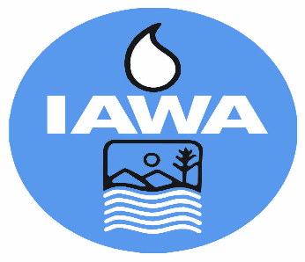
MEMBER REGISTRATION FORM
Illinois Association of Wastewater Agencies
101st Annual Conference – Sept. 16 – 18, 2025
I-Hotel & Conference Center, Champaign, IL
Starved Rock Lodge, Utica, IL
Name:
Agency:
Billing Address:
Phone:
Each person attending must fill out a separate form. Must be a member of IAWA or guest of a member to attend.
Registration fee for attending all Events | $375.00
If you will not be attending the following events, you may deduct the GSA Per Diem for the area.
I will not be attending the Wednesday Lunch | ($19.00)
I will not be attending the Thursday Lunch | ($19.00)
For head count purposes, please indicate if you will be attending:
I will be attending the Tuesday Reception
I will be attending the Annual Banquet on Wednesday
TOTAL
For head count purposes, please indicate if you will make a flower arrangement at Graceful Acres Farm (pay in person):
Mason Jar Free Design – no floral support ($40.00)
Professional Footed Vase with Reusable Design Support ($65.00)
Urbana/Champaign SD Tour-Thurs. (free – no transportation provided
CANCELLATIONS MUST BE RECEIVED IN WRITING BY THE IAWA OFFICE NO LATER THAN September 8, 2025 BEFORE 4 PM TO RECEIVE A REFUND.
Check Enclosed
Bill Me
Pay by Credit Card via Electronic Payment (Do not provide cc# on form)
Email address to send Invoice
Please make check payable to IAWA and email or mail with registration form to:
IAWA/ ATTN: Robin Dobbins
241 North 5th Street
Springfield, IL 62701 OR dobbins.robin@comcast.net
217/523-1814

