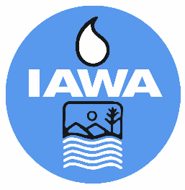
TRUSTEE ROUNDTABLE/FORUM REGISTRATION FORM
Illinois Association of Wastewater Agencies
101st Annual Conference– Sept. 16 – 18, 2025
I-Hotel & Conference Center, Champaign, IL

Name:
Agency:
Billing Address:
Phone:
Each person attending must fill out a separate form.
You must be a member of IAWA or a guest of a member to attend.
Registration fee for Trustees to attend Roundtable/Forum  Tuesday Reception and Wednesday AM Technical Session/Lunch Only. If planning to attend Wednesday Banquet, a full member registration form will be required | $100.00

CANCELLATIONS MUST BE RECEIVED IN WRITING BY THE IAWA OFFICE NO LATER THAN September 8, 2025 BEFORE 4 PM TO RECEIVE A REFUND.
Check Enclosed
Bill Me
Pay by Credit Card via Electronic payment (Do not provide cc# on form)
Email address to send Invoice
Please make check payable to IAWA and email or mail with registration form to:
IAWA
ATTN: Robin Dobbins
241 North 5th Street
Springfield, IL 62701
217/523-1814
dobbins.robin@comcast.net

