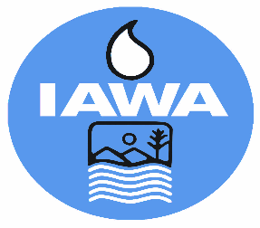

**SPOUSE REGISTRATION FORM**

Illinois Association of Wastewater Agencies

101st Annual Conference – Sept. 16 – 18, 2025

I-Hotel & Conference Center, Champaign, IL

Starved Rock Lodge, Utica, IL

|  |  |
| --- | --- |
| Name: |  |
| Spouse’s Name: |  |
| Billing Address: |  |
| Phone Number: |  |

|  |  |
| --- | --- |
| Registration fee for attending Tuesday Welcome Reception and Wednesday Annual Banquet | $150.00 |

|  |  |
| --- | --- |
| **For head count purposes, please indicate if you will make a flower arrangement at Graceful Acres Farm (pay in person):** |  |
| Mason Jar Free Design – no floral support ($40.00) |  |
| Professional Footed Vase with Reusable Design Support ($65.00) |  |
| Urbana/Champaign SD Tour- Thurs. (free – no transportation provided |  |

CANCELLATIONS MUST BE RECEIVED IN WRITING BY THE IAWA OFFICE NO LATER THAN **September 9, 2025 BEFORE 4 PM** TO RECEIVE A REFUND.

|  |
| --- |
| Check Enclosed |
| Bill Me |
| Pay by Credit Card via Electronic payment (Do not provide cc# on form)  Email address to send Invoice |

Please make check payable to IAWA and email or mail with registration form to:

IAWA

ATTN: Robin Dobbins

241 North 5th Street

Springfield, IL 62701

217/523-1814

[dobbins.robin@comcast.net](mailto:dobbins.robin@comcast.net)