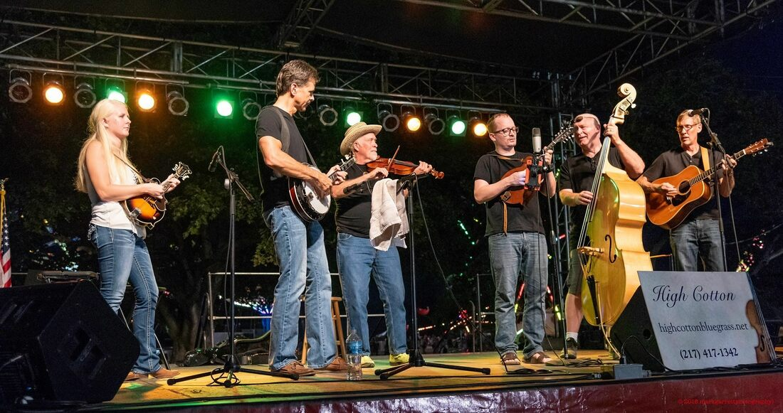
With a rich history spanning over two decades, High Cotton brings a unique blend of high-energy and soulful down-home bluegrass, folk, gospel, and bluegrassed country music to audiences of all ages. We take pride in being a family-friendly band that enjoys connecting with diverse audiences. Our performances are tailored to create a warm and inviting atmosphere for everyone, making us a perfect fit for a wide range of events and venues.
Over the years, we have entertained audiences across the Midwest, earning a reputation for our dynamic and engaging live shows. One of our strengths lies in the infusion of young talent into our band, ensuring a fresh and vibrant approach to our music. This influx of youthful energy complements our seasoned performers, creating a harmonious blend that captivates audiences and keeps them coming back for more. We believe that our ability to strike a balance between tradition and innovation sets us apart in the bluegrass scene.
High Cotton specializes in delivering tight harmonies that resonate with the soul of bluegrass music. Our commitment to musical excellence is evident in every note we play, and we take great joy in sharing our passion for this genre with those who appreciate authenticity and skillful performances.

