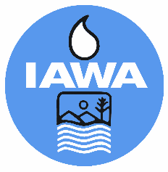
MEMBER REGISTRATION FORM
Illinois Association of Wastewater Agencies
Technical Committee Meeting
November 7, 2025 @ 10 AM
Starved Rock Lodge, Utica, IL
Agency:
Billing Address:
Phone Number:

Name (s) | $65/$75 Late Registration
TOTAL $

CANCELLATIONS MUST BE RECEIVED IN WRITING BY THE IAWA OFFICE NO LATER THAN November 3, 2025 BEFORE 4 PM TO RECEIVE A REFUND.
Check Enclosed
Bill Me

Please make check payable to IAWA and email or mail with registration form to:
IAWA
ATTN: Robin Dobbins
241 North 5th Street
Springfield, IL 62701
217/523-1814
Fax: 217/544-0086
dobbins.robin@comcast.net

