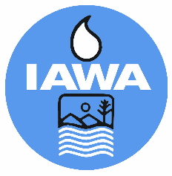
MEMBER REGISTRATION FORM
Illinois Association of Wastewater Agencies/CSWEA-IL Government Affairs
Mini Conference
March 10 – 12, 2026
Double Tree/President Abraham Lincoln Hotel, Springfield, IL
Agency:
Billing Address:
Phone Number:

Name | Mini-Conference  $149 | Central States  $70 | Wed Lunch  $39 | Total

CANCELLATIONS MUST BE RECEIVED IN WRITING BY THE IAWA OFFICE NO LATER THAN March 3, 2026 TO RECEIVE A REFUND.
Check Enclosed
Bill Me

Please make check payable to IAWA and mail with registration form to:
IAWA
ATTN: Robin Dobbins
241 North 5th Street
Springfield, IL 62701
217/523-1814
Fax: 217/544-0086

